 **30 Jan 2015** **The Weekly Bulletin of Rotary Club of Kathmandu Mid-Town** **bc-29/1.015**

|  |
| --- |
|  |

District: 3292 Web:www.rotarymidtown.org.np Club Id: 26776

**JANUARY IS ROTARY AWARENESS MONTH**

**Rotarians, clubs, and districts worldwide are encouraged to demonstrate**

**their commitment to family and community through projects, activities, and events in celebration of Family Month each December**

Club’s Weekly Meeting # 1263 on Friday, 23 January:

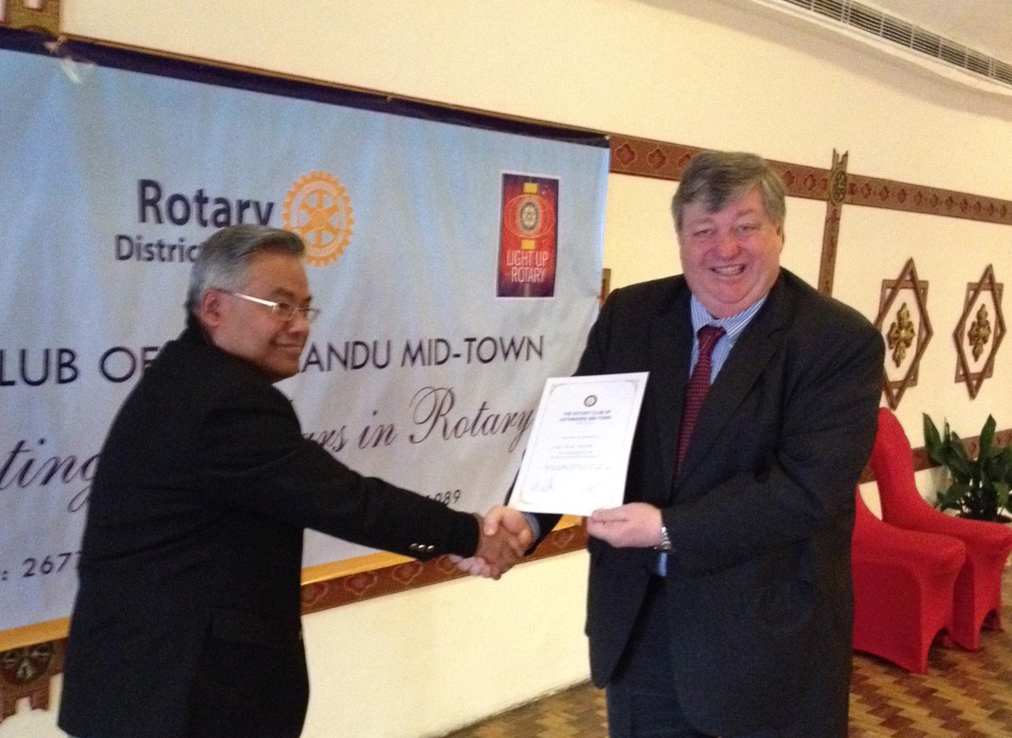

*Actg President Peter providing a letter of appreciation to Guest Speaker Sugat*

Extracts of the Meeting Minutes are given below:

“1. Acting President Peter called Meeting No.1263 to

order.

“6. PDG Yogendra introduced the Guest Speaker

Mr. Kansakar who had worked as Chief for Nepal

Airlines Corporation.

“7. Mr Kansakar spoke about "Delays in Govt.

Projects- A case Study of aircraft purchase episode

in Nepal Airlines Corporation”. He said that NAC

was not able to buy aircraft for the past 21 years. His

team was able to prepare “specification for tender”

within three months. He ensured that there were no

scandals. He said his team was able to content the

unions but the Cabinet, PAC and CIAA..

“8. Acting President Peter lauded Mr. Kansakar’s

effort and said how teams of talented people if given

opportunity are able to achieve goals.

“9. PP Komal, Rtn Bhairaja, PP Giridhar, PP CK,

took part in the discussion. Rtn Govinda gave vote of

thanks to Mr. Kansakar.

“10. Information sharing:

> PE Paras informed that PP William who had made some contribution had not received the rotary pins.

> PP Mani informed about the zonal membership seminar. PE Paras and Membership Chair Deepak were there.

> PP Mani also informed about the Gift of Sight Project to be held in Hetauda on 31 Feb.

> Registration Deadline for Rotary Peace Conference (7-9 FEB) extended until 25 January. Those attending the

conference make sure that their rooms are booked.

> PP Arun informed about the Mid Town Saturday Heritage Walk asking more members to join the walk. Those

willing to join are requested to contact PP Komal.

“11. Statistics of the meeting: Members present: 22”.

# Weekly Meetings and Programs :

|  |  |  |
| --- | --- | --- |
| Date | Program/ Speaker | Topic of Presentation |
| 30 January | Rt Gen Rookmangud Katwal, | ? . |
|  | or Basudev Dahal |  |
|  |  |  |

Friday, 30 January:

**Rotary South Asia Conference on Peace**

**Being held from 7 to 9 Feb at Lumbini Garden**

TRF Contribution

All those club/s, who want to be 100% contributory club this year (Minimum USD 10 per person), we will recognize the club from **RI President Gary C.K Huang on** 8 February 2015. So, we would like to request you to deposit the amount within 31st January 2015, so that we can make a necessary arrangement.

*- Rtn Basu Dev Golyan, PDG/DRFCC 2013-16*

Rota Quiz 2015:

Rota Quiz Semi Final is going to be held on 14 Feb 2015 in Kathmandu.

There will be 5 Semi-Final sessions to be followed by the Final round.

*Source: Dr. Harsha Ratna Shakya, Chair, Rota Quiz Sub-Committee*

7th District Conference

District Governor Rabindra Kumar Piya invites all Rotarians and guests to join us at the 7th District Conference of RI District 3292 on 27th, 28th Feb and 1st Mar, 2015 at Chitwan. District Conference Committee have been working hard to put together a terrific program that will be informative as it promotes “Enjoy Rotary"

Our conference will be an inspiring and enjoyable two and half days.  With interesting speakers, thought-provoking breakout sessions, two breakfasts, two lunches and two outstanding wonderful evening programs with dinner, we will “Light up Rotary.”

Please mark your calendar. We request to ,,,,,,,register as soon as possible. “Register NOW!”

*- Rtn Uttam Lal Chuke, Conference Chair*

**Walking Fellowship: Mid-Town Walking Circle**

Saturday, 20 Jan morning: Mid-Town Walking-Circle members (7) assembled at Jawalakhel.

They drove upto Bungmati bus station and went on culture-walk through Bungamati temple, Prathampur Mahavihar, Karya-Binayak temple and around.

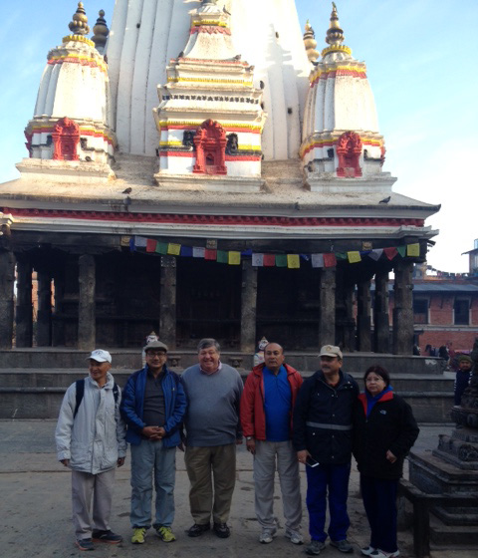 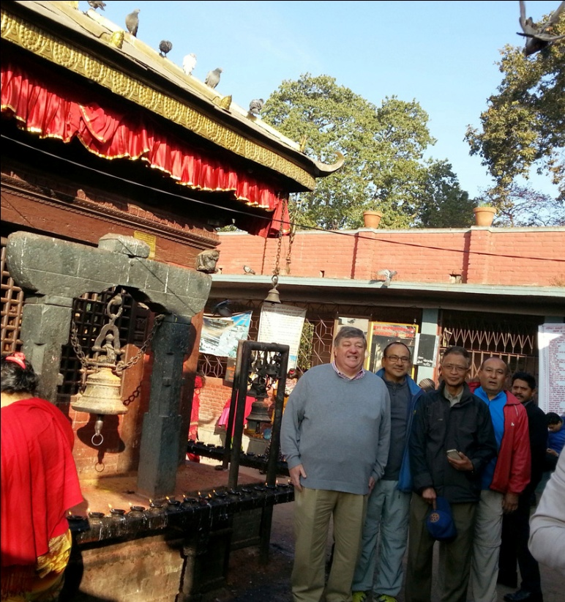

< Walking Circle members at Bungmati temple premises > < WC members at Karyabinayak Mandir >

**Garbage orbiting earth**



There are more than 300,000 pieces of debris larger than a centimeter in diameter orbiting earth. They range from tiny shards of metal to deactivated, decades-old satellites. Most are shrapnel from discarded rocket stages that have exploded after use, or satellites that have collided.

Colloquially, all this debris is usually called "space junk."

They range from tiny shards of metal to deactivated, decades-old satellites. Most are shrapnel from discarded rocket stages that have exploded after use, or satellites that have collided. Colloquially, all this debris is usually called "space junk."

Together, the Department of Defense and NASA track the orbits of the 19,000 or so pieces of junk that are larger than a softball, alerting satellite operators when any satellite — including the International Space Station — is in danger, so they can move it.

What's more, the cloud of debris has been steadily growing over time, and some scientists worry that if we're not careful, we could trigger a chain reaction: More space junk raises the chance of collisions, which in turn can lead to even more debris, until the sheer volume of space junk makes parts of space unusable.

"Space is a finite resource — just like the atmosphere, and the water, and the Earth," says [William Schonberg](http://care.mst.edu/facultyandstaff/departmentdirectory/profileschonberg/), an aerospace engineer who designs spacecraft to minimize damage from orbital debris. "We need to be careful about how we use it."

*Source: Internet News*

**A THOUGHT FOR TODAY:**

**A hero is someone who can keep his mouth shut**

**when he is right.**

Travel / Tourism

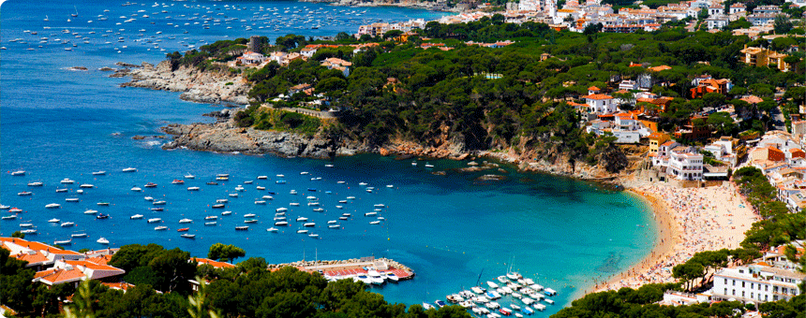

‘I would like to spend my whole life traveling, if I could borrow another life to spend at home’ William Hazlitt

On Lighter Side:

**A fine is a tax for doing wrong. A tax is a fine for doing well !**





Personal Note:

‘For certain personal engagement, I would not be able to attend club meetings in January and February, 2015. Further, I will be out of the country till the end July, 2015. Apology for this’: PP Devendra N Gongal

For many years, we in Rotary felt that it wasn't appropriate to boast about our good work.

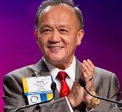

We felt it was best to serve quietly and let our work speak for itself. But today, in many

communities, people aren't even aware that they have a local Rotary club. Not because the

clubs aren't strong, or because they aren't serving well. They are. But if Rotarians don't talk

about their work, people will never know about it.

**RI President GARY C.K. HUANG**

## 30 January 2015 The Weekly Bulletin of Rotary Club of Kathmandu Mid-Town bc-29/1.015

*******************************